**Limit Order Entry Techniques For Long Term Traders**

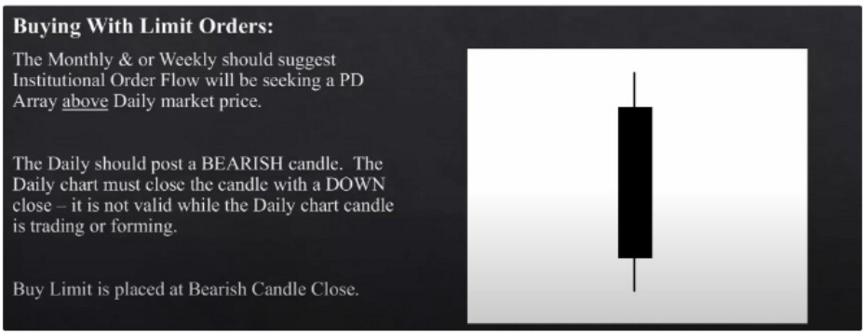

Open-

Close-

High



Low



--- Entry Buy Limit Here

This works the best when price has already shown its hand trough a market structure shift, and is in a DAILY PD array

You buy at an extreme discount, and youll get feedback immediately even on the daily

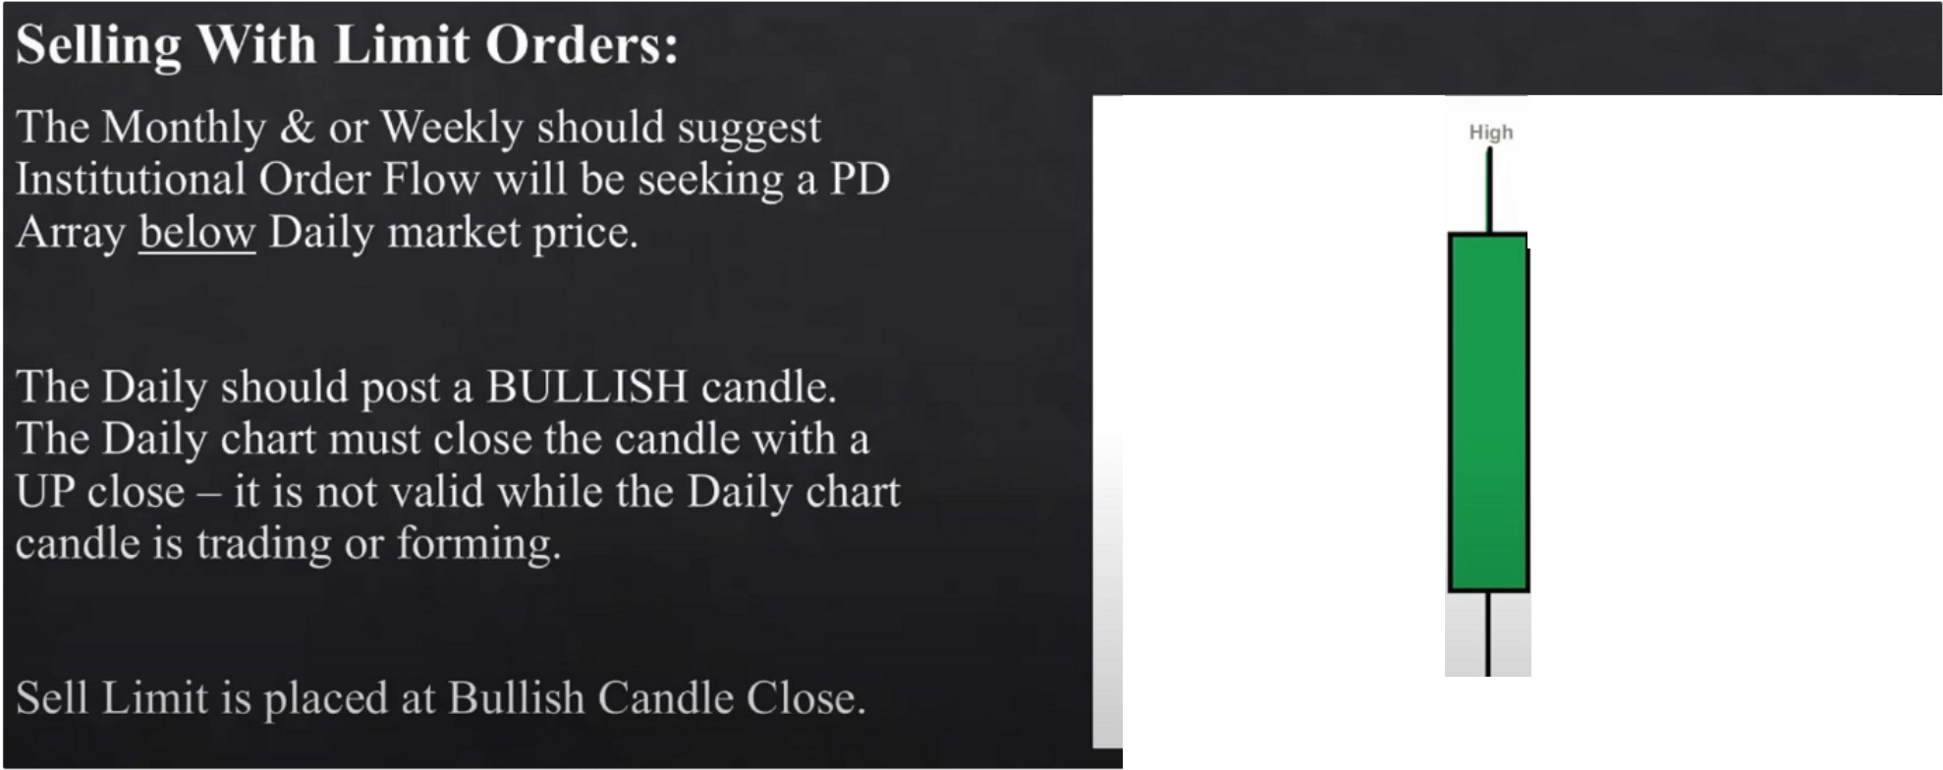

**Close +**

+--Entry Sell Limit Here

**Open +**

Low

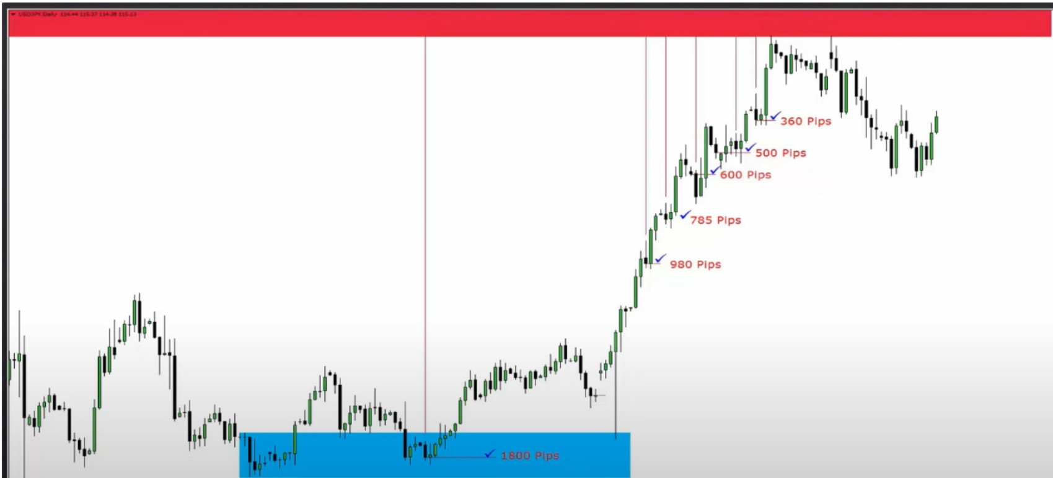

Arjo I Twitter, lnstagram I Linktree

Linktree. Make your link do more.

, https://t.co/HhmmTN1fUI

JavaScript is not available.

*"JI* https://twitter.com/arjoio